**Perimeter and Area-Questions**

Key Stage 3: 2003 Paper 1 Level 5-7

1.

Key Stage 3: 2003 Paper 2 Level 5-7

2.

3.

4.

Key Stage 3: 2003 Paper 1 Level 6-8

5.

Key Stage 3: 2003 Paper 2 Level 6-8

6.

7.

Key Stage 3: 2004 Paper 2 Level 4-6

8.

Key Stage 3: 2004 Paper 1 Level 6-8

9.

Key Stage 3: 2004 Paper 2 Level 6-8

10.

Key Stage 3: 2005 Paper 1 Level 5-7

11.

Key Stage 3: 2005 Paper 2 Level 5-7

12.

Key Stage 3: 2005 Paper 1 Level 6-8

13.

Key Stage 3: 2006 Paper 1 Level 5-7

14.

Key Stage 3: 2007 Paper 2 Level 5-7

15.

16.

Key Stage 3: 2007 Paper 1 Level 6-8

17.

Key Stage 3: 2007 Paper 2 Level 6-8

18.

Key Stage 3: 2008 Paper 1 Level 5-7

19.

Key Stage 3: 2008 Paper 2 Level 5-7

20.

21.

22.

Key Stage 3: 2008 Paper 1 Level 6-8

23.

24.

Key Stage 3: 2008 Paper 2 Level 6-8

25.

Key Stage 3: 2009 Paper 1 Level 5-7

26.

27.

28.

29.

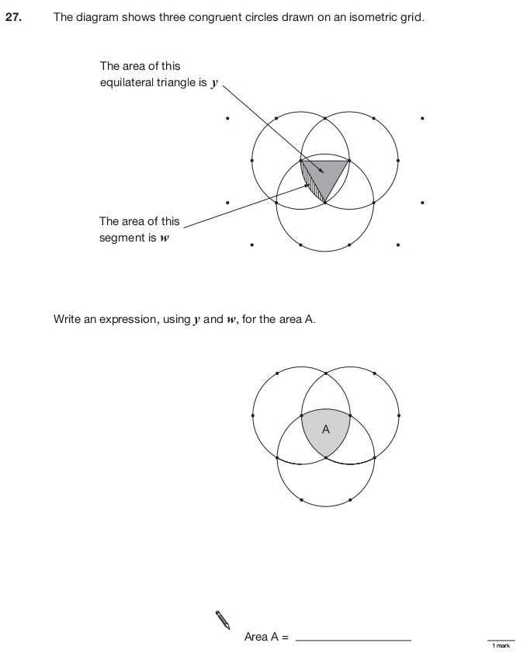

Key Stage 3: 2009 Paper 2 Level 5-7

30.

31.

Key Stage 3: 2009 Paper 1 Level 6-8

32.

33.

34.

35.

Key Stage 3: 2009 Paper 2 Level 6-8

36.

Key Stage 3: 2010 Paper 1 Level 5-7

37.

Key Stage 3: 2010 Paper 2 Level 5-7

38.

39.

Key Stage 3: 2010 Paper 2 Level 6-8

40.

41.

Key Stage 3: 2011 Paper 1 Level 5-7

42.

43.

Key Stage 3: 2011 Paper 2 Level 5-7

44.

45.

46.

